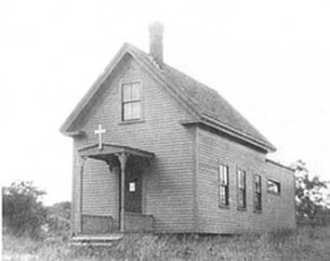
All Saints Parish
"The first services of the Episcopal Church held in Whitman were conducted in several local homes by The Rev. George Alexander Strong, Rector of St. Paul's Church of Brockton, during the Lenten season of 1897. Rev. Mr. Strong discussed the plan of holding regular services and starting a Mission (under the auspices of St. Paul's). It was the Sunday before All Saints' Day, 1897 (Oct. 31) that the first regular service was held in Jenkins' Block, and the date helped in deciding the name of All Saints' Mission." (from a History by Mary Kalor Hutchinson, 1910)
In 1905, the Mission came under the direct auspices of the Episcopal Diocese of Massachusetts. In October 1908, the first Parish meeting voted, "to purchase for $2000, property on the northerly side of Park Avenue from Clara M. Corthell." This land was occupied by an old machine shop. Mr. Clayton M. Legge, the first Vicar, was responsible for the drive to remodel the machine shop into a chapel. He then set about leading the members in fundraising for a new building. "The turning of the first sod for the new church cellar took place on the fifth Sunday in July 1910 (July 31)." (M. Hutchinson) August 31, 1910
The cornerstone was laid by Bishop Lawrence, in an impressive service. The stone is engraved with a cross and "1910."
The wooden cupola and cross were deemed to be hazardous, and removed on October 11, 1962. The cross was fashioned into many small crosses (by Herb Finnegan, it is believed), of which one still remains in the possession of a long-time Parishioner.
August 31, 1910 – The Cornerstone was laid by Bishop Lawrence, in an impressive service. The stone is engraved with a cross and 1910.
December 30, 1910 – The Church building was completed, and a Dedicatory Service was held. Bishop Lawrence preached the sermon and confirmed 8 persons. A few years later, two stained-glass windows created by John LaFarge were added, donated by the Episcopal Theological Seminary.
December 16, 1928 – It was voted to purchase the Luddy House at the corner of Washington Street and Myrtle Avenue, for a Rectory.
March 13, 1953 – “Favorable vote of the Standing Committee of the Diocese on our application for admission into union with the Convention as a Parish.”
May 29, 1953 – “Plans for attaching a suitable structure to the rear of the present Church” resulted in the addition of a parish hall, named for Rev. Matteson, on the East side of the Church.
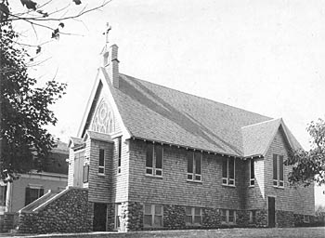
The church building, probably taken in the 1940's, before the addition of the parish hall.
February 12, 1954 – Good Friday ecumenical 3-hour Services began at All Saints.
January 9, 1966 – Holy Communion was celebrated only on the third Sunday at Family Service, all other Sundays being Morning Prayer. This was standard here until 1985.
November 11, 1966 – A dinner was held to celebrate the burning of the Parish Hall mortgage.
1968 – The Undercroft was divided into 4 small rooms.
1983 -- The Rectory at 708 Washington Street was sold for $31,000. Proceeds of the sale were put into a fund to make mortgage loans to Rectors.
1989 – A new electronic organ was installed to replace the beloved pipe organ, deemed too expensive to repair.
1998 – A building program added a handicapped access restroom to the Parish Hall and 3 classrooms in the basement.
2000 – Annual Meeting voted to proceed with a handicap-access elevator to the Sanctuary.

Clergy 1897 - present
As a Mission under governance of St. Paul’s, Brockton:
Rev. George Alexander Strong | 1897 | Rector, St. Paul’s Church, Brockton
Layreaders under governance of St. Paul’s Brockton from 1897-1903:
Mr. Ralph Parsons Smith |  | Senior at Episcopal  Theological Seminary, Cambridge.
Mr. Donald Mayo Brookman
Mr. Harlan H. Ryder
Mr. Thomas Clyman Campbell
Rev. Francis Bingham White | 1903? | Rector, St. Paul’s
As a Mission under governance of the Diocese:
Mr. William E. Williamson | 1905 | Layreader
Mr. Frank R. Rathbone | 1908 | Layreader
Mr. Clayton M. Legge | 1909-10 | Layreader, later First Vicar
Mr. Patton | 1911-14 | Shared with Braintree
Mr. Hughes | 1914 | Interim
Rev. John Matteson | 1914-39 | Shared with Rockland
Rev. Alfred Longmeier | 1940-49 | Vicar
Rev. Charles Boyd | 1950-53 | Vicar
As a Parish:
Rev. J. Franklin Rudderham | 1954-72 | Rector
Rev. Donald Miller | 1972-77 | Rector
Rev. William Fox | 1977 | Interim
Rev. Norman R. Meservey | 1978-83 | Rector
Rev. Dale Van Meter | 1983 | Interim
Rev. Thomas R. White | 1984-92 | Rector
Rev. William Eddy | 1992-3 | Interim
Rev. James “Dutch” Nelson | 1993 | Interim
Rev. Dana F. Boynton | 1994-2002 | Rector
Rev. Edward Boucher | 2002-3 | Interim
Revs. Doug & Patti Hale | 2003-7 | Co-Rectors
Rev. Patti Hale | 2008- | Rector

