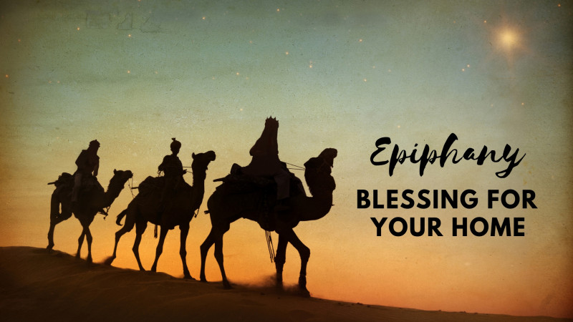

Holy Graffiti:
a blessing for all who enter your home

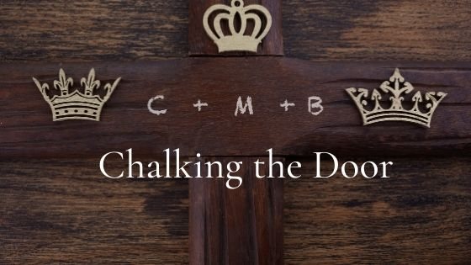

What Is Chalking the Door?
This short liturgy is a way of marking our homes, usually at the front or main entrance, with sacred signs and symbols as we ask God’s blessing upon those who live, work, or visit throughout the coming year. In Exodus, the Israelites marked their doors with blood so that the Lord would pass over their homes; but in this service, we mark our doors with chalk as a sign that we have invited God’s presence and blessing into our homes
In Deuteronomy 6:9 God tells the people of Israel: “These words that I command you today shall be on your heart. You shall teach them diligently to your children, and shall talk of them when you sit in your house… You shall write them on the doorposts of your house and on your gates.” Chalking the door is a tangible way to honor God in our lives.

What Do the Numbers and Letters Mean?
The first and last numbers simply refer to the current year. The letters C M B come from the traditional names for the three kings: Caspar, Melchior, and Balthazar. CMB also means “Christus Mansionem Benedicat” which means, “May Christ bless this dwelling!”

This liturgy may be done by an individual or by all who live in the home.
Leader: Peace be to this house, and to all who enter here.
People: Amen.
The following prayers are said.
May all who come to my/our home this year rejoice to find Christ living among me/us; and may I/we seek and serve, in everyone I/we meet, that same Jesus who is your incarnate Word, now and forever. Amen.
God of heaven and earth, you revealed your only-begotten One to every nation by the guidance of a star. Bless this house and all who inhabit it. Fill me/us with the light of Christ, that my/our concern for others may reflect your love. I/We ask this through Christ our Savior. Amen.
Loving God, bless this household. May I/we be blessed with health, goodness of heart, gentleness, and abiding in your will. I/We ask this through Christ our Savior. Amen.
All who live in the house may take turns inscribing or a leader may do all the writing, or the individual may chalk the door.
Write on the door: 20 + C + M + B + 22
Pray: The three Wise men Caspar, Melchior and Balthazar followed the star of God’s Son who became human two thousand and twenty-two years ago. May Christ bless our home and remain with us through this new year.
The Lord’s Prayer
Our Father who art in heaven,
hallowed be thy name.
Thy kingdom come.
Thy will be done
on earth as it is in heaven.
Give us this day our daily bread,
and forgive us our trespasses,
as we forgive those who trespass against us,
and lead us not into temptation,
but deliver us from evil.
For thine is the kingdom and the power, and the glory, forever and ever. Amen.
Closing Prayer: Visit, O blessed Lord, this home with the gladness of your presence. Bless all who live or visit here with the gift of your love; and grant that we may manifest your love to each other and to all whose lives we touch. May we grow in grace and in the knowledge and love of you; Guide, comfort, and strengthen us to peace, O Jesus Christ, now and forever. Amen.

